Training Rats using BehGUI

**PRELIMINARY**

1. First be sure auto focus is turned off in main camera. See Appendix for instructions:
2. Be sure volume is turned all the up on computer (bottom right of screen)
3. Be sure there are pellets in the hopper.

**MAIN PROCEDURE**

1. Start Beh_GUI_MAIN.py
2. Double click in box below “EXPT FILE NAME”. This file describes how the experiment will run. Select the appropriate protocol file in C:\Users\ephys-2\Documents\GitHub\py-behav-box\TNEL-pyBox\BehGUI\PROTOCOLS.
3. Type in the SUBJECT name in the box to the left of “SUBJECT” on the GUI. Then press enter.
4. Press the “START EXPT” button. That’s it. Experiment is done when GREEN LED above “START EXPT” button goes off.

CAUTION: DO NOT OPEN DATA FILES WHILE EXPERIMENT IS RUNNING!!!

If opened by another program, data may NOT be logged.

APPENDIX

To turn off autofocus feature on camera, do the following:

* Click on Debut video Capture icon .
* Select tools -> options.

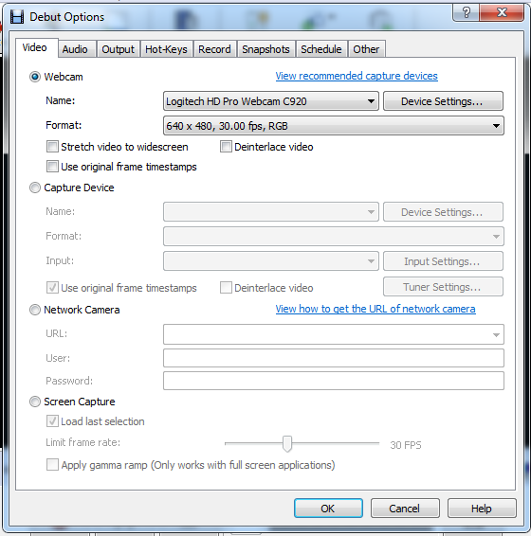

* Then select Logitec HD Pro Webcam C920 if not already selected.
* Click on “Device Settings” then “Change Device Settings” in the pop-up window, then
* Be sure the “Auto Focus” box is UN-checked.

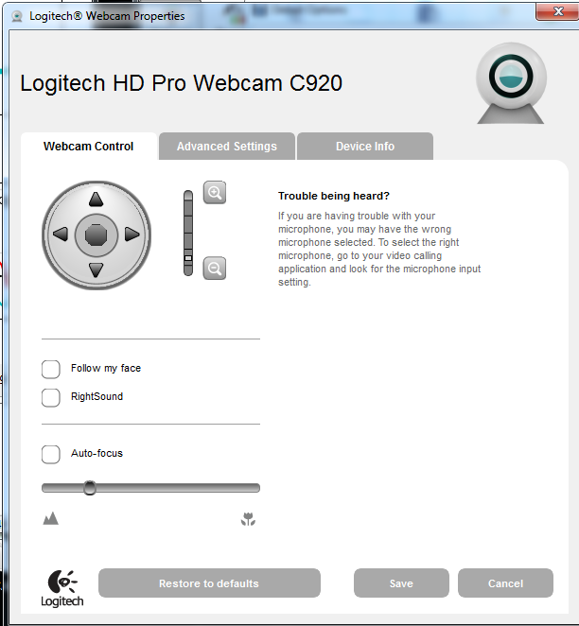

* Press the “Save” button, then the “OK” button.

Now you should be good to go.